OneAgent Installation on Linux VM
Step 1 – Verify Linux Environment
uname -a
free -m
df -h
Step 2 – Download Installer
Login to Dynatrace UI
Navigate:
Deploy Dynatrace → Linux
Copy command like:
sudo /bin/sh Dynatrace-OneAgent-Linux.sh APP_LOG_CONTENT_ACCESS=1
Run in VM.
Expected Output:
- Installation successful
- OneAgent service started
Step 3 – Validate Service
sudo systemctl status oneagent
Should show:
Active (running)
Check logs:
sudo journalctl -u oneagent
Step 4 – Validate in UI
Navigate:
Deploy Dynatrace → Hosts
Verify:
- Host appears
- CPU metrics visible
- Memory metrics visible
Step 5 – Investigate Host Details
Open Host → Overview
Check:
- CPU usage
- Memory consumption
- Disk usage
- Network traffic
Lab 2 Infrastructure-Only Mode vs Deep Monitoring
Step 1 – Review Monitoring Modes
Deep Monitoring:
- Code-level tracing
- Service detection
- PurePath traces
Infrastructure-only:
- Host metrics only
- No application code visibility
Step 2 – Switch to Infra-Only Mode
Navigate:
Deploy Dynatrace → Hosts → Select Host → Monitoring Mode
Change to:
Infrastructure-only
Wait 2–3 minutes.
Observe:
- Processes disappear
- Only CPU/Memory visible
Step 3 – Switch Back to Full Stack
Enable:
Full Stack Monitoring
Observe:
- Processes auto-discovered again
When to use Infra-only?
- Database servers
- Security restrictions
- Licensing optimization
Lab 3 – Process Auto-Discovery & Analysis
Step 1 – Generate CPU Load
Run:
yes > /dev/null &
Check PID:
top
Observe high CPU process.
Step 2 – Observe in Dynatrace
Navigate:
Host → Processes
Check:
- New process detected?
- CPU usage reflected?
OneAgent auto-detects all running processes.

Step 3 – Install Apache (Optional)
sudo apt install apache2 -y
sudo systemctl start apache2
Open browser:
http://<VM-IP>
Check Dynatrace:
- Apache process detected?
- Technology identified?

Step 4 – Process Details
Click process → Analyze:
- CPU usage
- Memory usage
- Threads
- Command line
How does Dynatrace detect technologies automatically?

Lab 4 – Host Metrics Deep Analysis
Reference UI
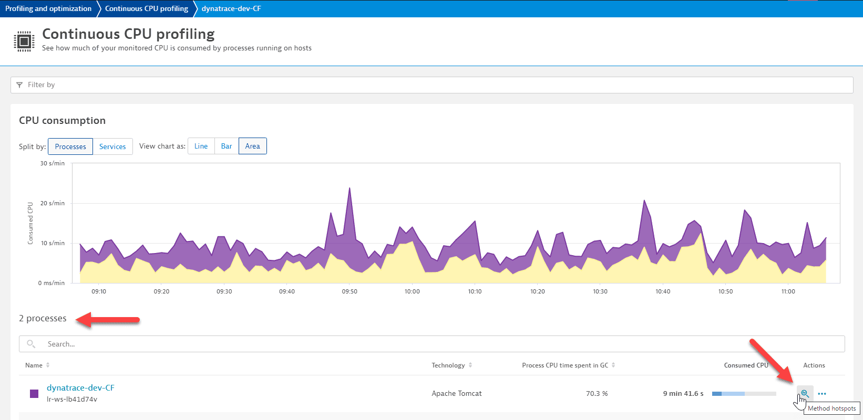
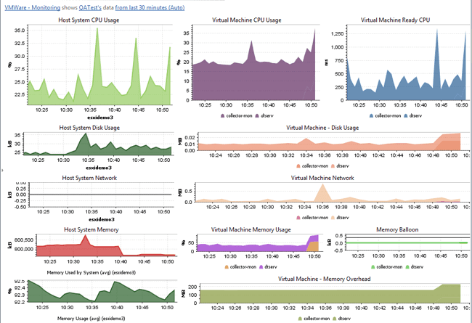
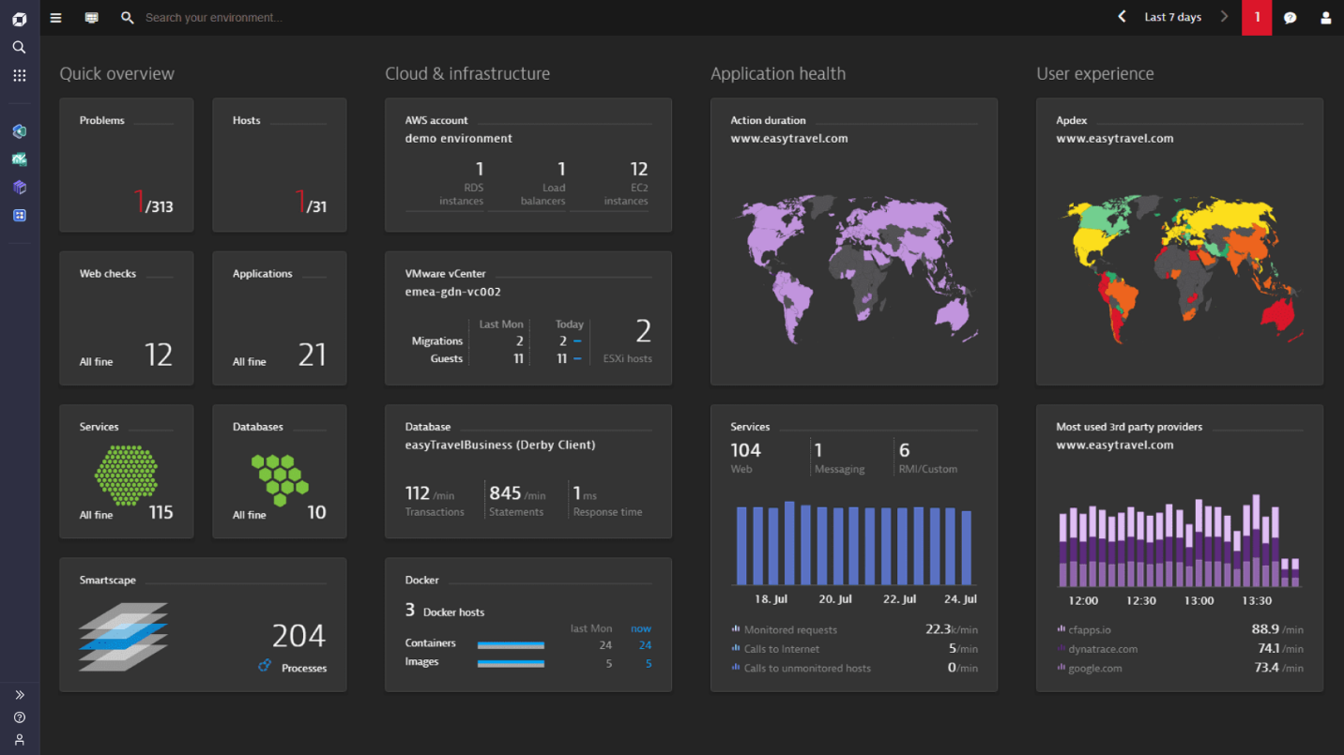
Step 1 – CPU Analysis
Navigate:
Host → CPU
Observe:
- User time
- System time
- IO wait
What indicates CPU bottleneck?
Step 2 – Memory Analysis
Navigate:
Host → Memory
Observe:
- Used memory
- Available memory
- Swap usage
Trigger memory stress:
sudo stress --vm 1 --vm-bytes 500M --timeout 60
Observe memory spike.
Step 3 – Disk Analysis
dd if=/dev/zero of=testfile bs=1M count=500
Observe:
- Disk write throughput
- Disk IO wait
Delete file after test.

Step 4 – Network Analysis
Ping external:
ping google.com
Check network traffic metrics.

Lab 5 – Connectivity & Firewall Validation
Step 1 – Check Port Connectivity
curl -v https://<your-environment-id>.live.dynatrace.com
Should return HTTP response.
Step 2 – Block Port 443 (Simulation)
sudo iptables -A OUTPUT -p tcp --dport 443 -j DROP
Observe:
- Host goes offline in Dynatrace after few minutes.
Remove rule:
sudo iptables -D OUTPUT -p tcp --dport 443 -j DROP
Observe:
- Host reconnects.
Why no inbound firewall rule required?
Lab 6 – Basic Troubleshooting
Scenario 1 – Agent Not Running
sudo systemctl stop oneagent
Observe in UI:
- Host becomes unavailable
Start again:
sudo systemctl start oneagent

Scenario 2 – Check Agent Logs
sudo /opt/dynatrace/oneagent/agent/tools/oneagentctl --status
Review logs:
sudo cat /opt/dynatrace/oneagent/agent/log/oneagent.log

Lab 7 – Smartscape & Topology Validation
Open:
Smartscape → Hosts & Processes
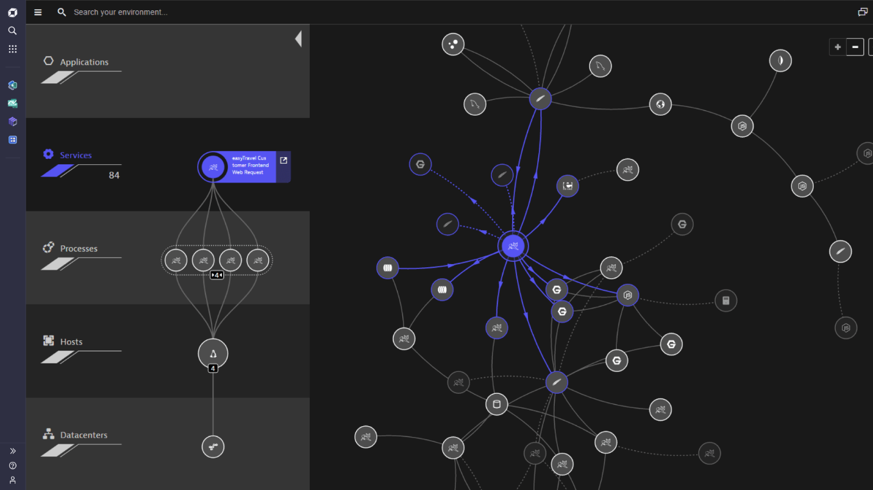
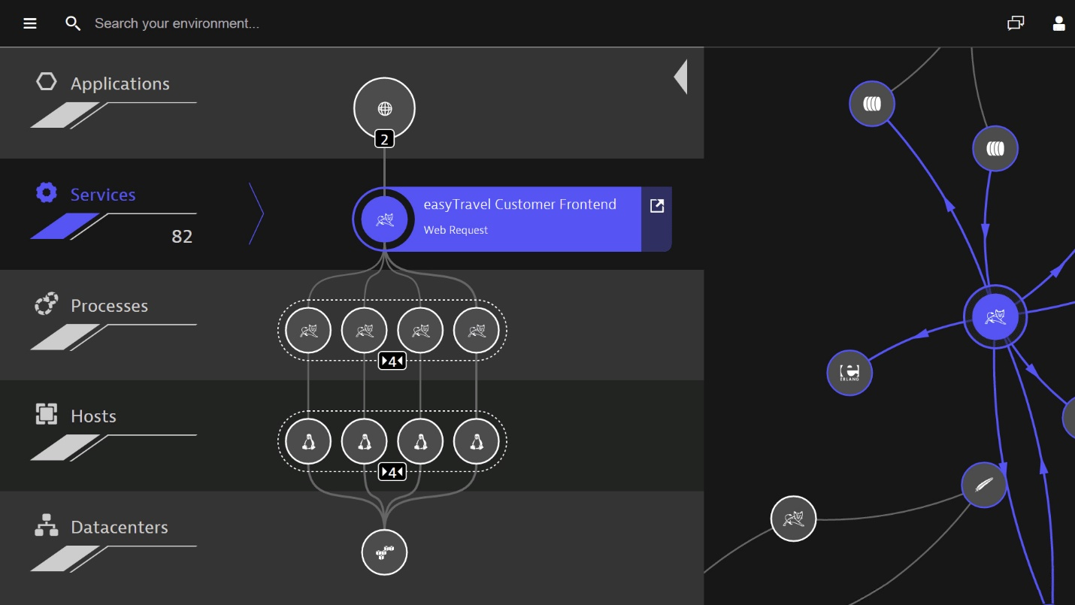
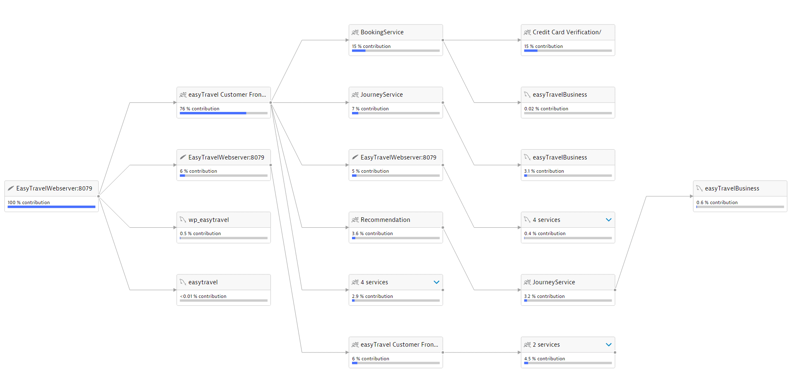
Observe:
- Host
- Processes
- Services (if Apache installed)
Smartscape builds topology automatically.

